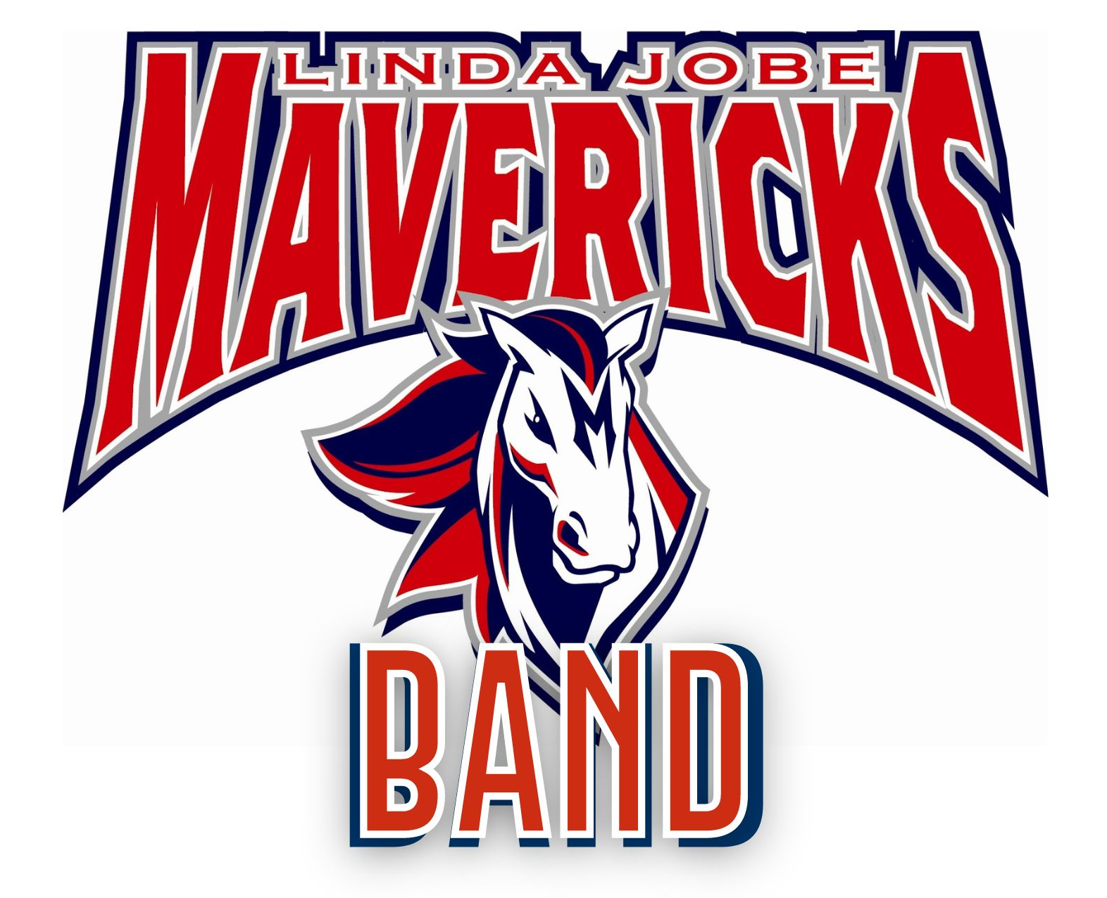
2022 - 2023 JOBE HONORS BAND
HANDBOOK & CALENDAR CONTRACT PAGE

Student Last Name_________________________First Name:_________________

Instrument:__________________________Class Period:____________________

PARENT INITIAL ON EACH SPACE BELOW:

_____I have read, understand, and agree to follow the rules and expectations of the Jobe Maverick Band as stated in the 2022-2023 Band Handbook.

_____I understand that it is my responsibility to update my contact information on Skyward whenever I have changes. I am aware that the directors will use this information in order to stay in contact with me and help me stay up-to-date.

I am aware that the following dates are required curricular events/performances for my child and if missed, may result in a lowered class grade and/or possible removal from the Honors Band. Dates that are pending administration approval will be sent home by mid-September if they are altered.

_____ 10/15 All-District Band Auditions

_____ 11/5 and 11/8 All-Region Band Auditions

_____ 12/7 Winter Band Concert - pending MISD Fine Arts Administration schedule approval

_____ 3/8 and 3/9 Pre-UIL Concert during the school day

_____ 4/3 - 4/6 UIL Concert and Sightreading Contest - during one of these school days.

_____ 5/16 Spring Band Concert - pending MISD Fine Arts Administration schedule approval

_____I am aware that Private Lesson Teachers are available to help support my child and give them individual attention. Private lessons are strongly encouraged for members of the Honors Band.

Please check one.
_____Interested in lessons, please give my info to a private lesson teacher.
_____Interested in lessons, I will contact a teacher myself.
_____Not interested at this time.
_____Already taking lessons from_________________________ (lesson teacher's name)

Parent Signature___________________________________________Date______________

Student Signature___________________________________________Date______________

Please return this sheet to the band directors on or before
Wednesday, August 24, 2022.

