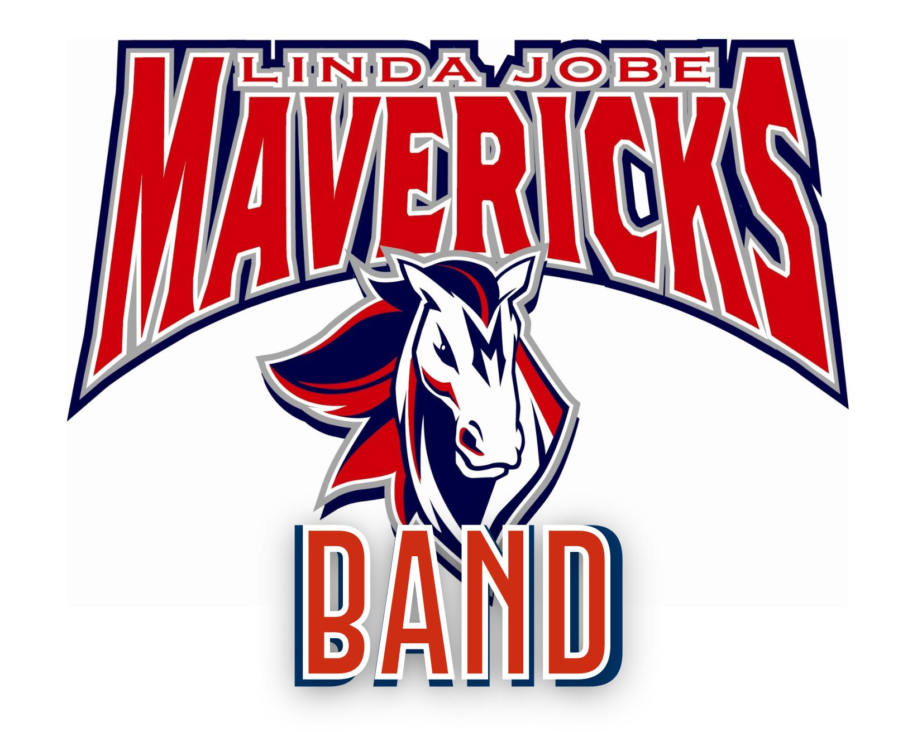

Band Handbook
2022 - 2023

“Always a Great Day to be a Maverick”

Jobe Middle School
Maverick Band
2491 Gertie Barrett
Mansfield, TX 76063
682.314.4444

Dear Students and Parents,

The Jobe Middle School & Legacy High School music staff, alongside the MISD administration, have put together a set of Music Program Guidelines to provide band students and parents as much information as possible about our Band program. Required guidelines published in this handbook provide general information about our program which we hope you will find helpful.

Students who enter our band program can look forward to a comprehensive, sequential music education that will take them through the 12th grade. Our 7th grade middle school beginning band program emphasizes a thorough foundation in individual performance fundamentals. Students in the 7th and 8th grade, who have completed one year of beginning band, will perform in the full band setting with an emphasis on developing ensemble concepts and furthering individual skills. Once your student reaches the high school level, they will have the opportunity to participate in a wider range of performing ensembles including marching band, concert band, jazz band, as well as individual, community, and national performances.

We are proud of the tradition of excellence that our band program enjoys. With your help and support, we look forward to continuing this tradition of educational excellence in music.

If you have questions regarding the Jobe Middle School Band Guidelines and information contained in this handbook, please call the band office at 682.314.4444.

Sincerely,

Mrs. Elisabeth McConnell
Director of Bands
Jobe Middle School
Donna Shepard Leadership Academy

PHILOSOPHY OF THE MAVERICK BAND

The success of the Jobe Middle School Band centers on pride, commitment to task, and strives to achieve a common goal. We do not expect every student in the program to become a virtuoso musician. We do expect every student to establish both short and long term goals for improvement on their instrument, to exhibit mature, responsible attitudes and actions at all times, and be willing to contribute substantial effort for the benefit of all.

The band program exists to provide an excellent music education for the students. This is achieved through individual study and varied performances in many venues which supports a curriculum that places an emphasis on comprehensive musicianship. Performance opportunities include large ensembles, chamber ensembles and solos. The skills that band students acquire in these activities are directly related to skills necessary for auditions, presentations, and interviews in other career fields.

Opportunities are also provided for those who wish to develop their leadership skills. There is an extensive student leadership program, and student leaders are relied upon to help achieve organizational goals. These opportunities are provided through the Band Leadership Team.

Social skills are also developed. Participation in band enables the students to form close friendships within the school through their collaborative efforts and the opportunity to work with their peers as part of a team. As a member of the Maverick Band program, students make long-lasting friendships and develop a sense of camaraderie that is unique to our organization. Organizational goals are clearly established, and the students depend heavily on each other to achieve them. As a result, the concepts of responsibility, teamwork and good citizenship will develop as each student experiences the world of music.

The ultimate goal of the program is to produce students who are knowledgeable about music, can perform successfully with confidence, can operate within a structured framework, and can work to develop the skills necessary to continually become a strong person.

Band activities are group events that require the commitment of ALL STUDENTS. All group performances require mandatory attendance from each student. We ask each Maverick Band Family to make a strong commitment to the Band Calendar. Please communicate with the director if you foresee any conflicts. All students are required to attend the events pertaining to their particular band. Band events may sometimes conflict with another JMS school event. In that case, the director will work with the student to see that their best interests are met. Non-school related activities should never take priority over a Jobe Middle School related event.

Every year is a new challenge – new combinations of personalities and talent, new audiences, new music, new members, and new leadership. By accepting membership in the Jobe Middle School Band, students agree to perform to the best of their abilities and work together with the band staff to make this year’s band the finest musical organization that our combined efforts can produce.

CONTACTING THE DIRECTORS

The band staff is available to meet the needs of all students in the Jobe band program. Please do not hesitate to contact the directors if you have questions or concerns and please allow 24 hours for a response.

Elisabeth McConnell, Head Band Director - (682) 314-4444 - elisabethmcconnell@misdmail.org Roman Montoya, Associate Band Director - (682) 314-4445 - romanmontoya@misdmail.org
Nicholas Thomas, Associate Band Director - (682) 314-4445 - nicholasthomas@misdmail.org
Chris Vasquez, Legacy Cluster Percussion Director - (682) 314-4445 - alanvasquez@misdmail.org

CLASS SCHEDULE

Morning Sectionals | 7:45 – 8:30am | Schedule to be determined
1st Period | 8:30 – 9:15am | Donna Shepard Beginning Class
2nd Period | 9:18 – 10:03am | Donna Shepard Beginning Class
3rd Period | 10:06 – 10:51am | Donna Shepard Beginning Class
4th Period | 10:55 – 12:29pm | Travel/Conference/Lunch
Advisory | 12:33 - 12:59pm | Advisory - McConnell/Montoya/Thomas
5th Period | 1:03 – 1:48pm | Honors Band – McConnell  (Percussion - Vasquez)
6th Period | 1:52 – 2:37pm | Symphonic Band – Montoya/Thomas  (Percussion - Vasquez)
7th Period | 2:41 – 3:26pm | Beginning Band - McConnell/Montoya  Thomas
8th Period | 3:30 – 4:15pm | Team Planning – McConnell/Montoya  Thomas
Afternoon Sectionals | 4:20 – 5:05pm | Schedule to be determined
COURSE OBJECTIVES

In recent decades, research has supported what musicians have long understood. Music is a unique and essential element of human experience with numerous cognitive and physiological benefits to those who study it. Although there has long been evidence of the direct correlation of musical understanding to achievement in other academic areas, Howard Gardner was among the first to identify that music is in and of itself a separate form of intelligence. Since then, brain research has continued to reveal that formal study of music as one of the most powerful means of tapping students’ cognitive and emotional potential. Furthermore, participation in an organized musical activity produces the same intrapersonal and interpersonal benefits long attributed to team sports and similar activities.

In accordance with established best practices and the philosophy of the Jobe Band program, students enrolled in band will be expected to demonstrate the skills listed below upon completion of the school year.

Students will:
- Demonstrate the correct posture and playing position for their instrument.
- Demonstrate proper tone production and instrumental timbre for their instrument.
- Demonstrate the physical skills necessary to properly perform their instrument.
- Perform accurately and independently musical selections of appropriate difficulty.
- Demonstrate proper breathing techniques required for playing a wind instrument.
- Demonstrate understanding of proper articulation and stylistic markings and apply these to music.
- Demonstrate understanding of all standard dynamic markings and apply these to performed music.
- Demonstrate and apply common indicators of tempo.
- Identify a variety of common musical terms and apply them to performed music.
- Demonstrate knowledge of rhythmic notation and counting in a variety of meters according to accepted practice.
- Demonstrate the ability to tune using both aural recognition and electronic measurement.
- Identify the intervallic relationships of notes within major keys.
- Identify the inherent intonation flaws of their instrument as well as proper methods of compensation.
- Demonstrate the ability to critically evaluate both live and recorded musical performances.
- Perform at least seven major scales and the chromatic scale by memory and without errors.
- Demonstrate knowledge and application of proper instrument care and maintenance.
- Demonstrate the characteristics of self-discipline both in class and at home as it relates to proper practice and execution of performance skills.
- Demonstrate the ability to work cooperatively and collaboratively with students within a performing ensemble.
- Demonstrate proper performance etiquette, both as a performer and as an audience member.
- Perform successfully in formal concerts according to established criteria.
PERFORMING ENSEMBLES

All Jobe Band students are placed into ensembles based upon their ability level at the end of last school year. These ensembles are: Honor Band, Symphonic Band, and Beginner Band.
HONOR BAND
The Honor Band is Jobe Middle School’s advanced performing ensemble. They officially represent the school and perform throughout the year.

Members of the Honor Band:
- set the standard in musicianship, integrity and professionalism
- are expected to practice the required amount to maintain growth as a musician
- adhere to our state’s “No Pass/No Play” law that each student maintains a 70 or higher in all classes (Pre-AP classes must be a 60 or higher)
- are required to attend all performances - missing a performance may result in a lowered grade, missing the spring festival trip, and/or removal from the Honors band
- are strongly encouraged to enroll in private lessons
- are required to attend section rehearsals year round, strongly encouraged to audition for the All-District and All-Region Band, and perform at Solo & Ensemble Contest

SYMPHONIC BAND
The Symphonic Band is Jobe Middle School’s intermediate performing ensemble. They also represent the school and perform throughout the year.

Members of the Symphonic Band:
- adhere to the standard of musicianship, integrity and professionalism
- are expected to practice the required amount to maintain growth as a musician
- adhere to our state’s “No Pass/No Play” law that each student maintains a 70 or higher in all classes (Pre-AP classes must be a 60 or higher)
- are strongly encouraged to enroll in private lessons
- are required to attend scheduled section rehearsals starting in January, and perform at Solo & Ensemble Contest

BEGINNER BAND
The Beginner Band is Jobe Middle School’s class where students are taught how to play an instrument for the first time. This class is meant for new band students, not those who wish to play a different instrument. They will also represent the school and perform throughout the year at a few concerts.

Members of the Beginner Band:
- are expected to practice the required amount to maintain growth as a musician
- adhere to our state’s “No Pass/No Play” law that each student maintains a 70 or higher in all classes (Pre-AP classes must be a 60 or higher)
- are strongly encouraged to enroll in private lessons
- are required to attend concerts, and perform at Solo & Ensemble Contest
CALENDAR OF EVENTS

Along with this handbook, each student will receive a calendar of band activities for the school year. All attempts are made to provide accurate information, but some adjustments to this calendar may have to be made during the school year. The directors will provide updated information to students as soon as possible should the need arise. Students will be responsible for informing their parents of any changes to the calendar in a timely manner. Parents are responsible for marking performance events on the family calendar so that conflicts do not arise.

Students are required to participate in all scheduled band activities unless noted otherwise. Absences are only excused in accordance with established district criteria. Conflicts with non-school activities (sporting events, etc.) are not excusable reasons for missing a scheduled activity. Parents are required to plan ahead to resolve any conflicts with scheduled band activities. Unexcused absences from a required activity can result in a lowering of the student’s grade, removal from the Honors band, ineligibility to attend the spring festival at NRH2O, and/or disciplinary action depending on the circumstances. Some individual events (All-Region Band auditions and Solo and Ensemble Contest) allow for flexibility in scheduling for each student.

ABSENCE PROCEDURES

Unlike most other academic classes, it is not possible to make up missed content in performance-based band classes. The art of musicianship is temporal, and it is necessary to be present in order to benefit from music instruction. Alternate assignments may be given to students who are absent in order to satisfy grade requirements, but there is no substitute for the information presented in class.

As stated numerous times in this handbook, students are expected to attend all scheduled band rehearsals and performances. If it is absolutely necessary to miss a performance, a written note by a parent must be presented to the director at least 24 hours prior to a scheduled rehearsal and at least two weeks prior to any performance. The note must include the specific reason for the absence or it will be automatically considered unexcused. Unexcused absences may result in a lowered grade, loss of privileges, and/or reassignment to a different part or role within the band.

An absence from a performance or rehearsal will be considered excused if the absence is due to illness, family emergency (illness, death, etc.), religious observance, or certain school-related schedule conflicts. Non-school activities and transportation arrangements are not considered excused absences.

In the event of a sudden illness or family emergency prior to a rehearsal or performance, the student should call his or her director’s school number and leave a message. A written note meeting the same criteria as in the previous paragraph may then be brought to the director following the performance.

The band is an interdependent organization. Every student is important to our success, and we cannot teach to an empty chair. Please do not schedule non-emergency doctor appointments and similar events during your child’s band class if at all possible or other scheduled rehearsals and performances.

GRADING POLICY

Band is a curricular course. As such, students will be graded on all activities pertaining to the established curriculum for the course in which they are enrolled.

Grades in band are calculated on a 100-point scale. A grade of 70 or higher is required to pass each six-weeks grading period. Grades are calculated in the following manner:

Major Grades (20%)
Sectionals
Clinician Rehearsals
Class Playing Assignments
Objective Sheets
Written Exams
Performance Grades(30%)
Individual/Group Performances

Daily Grades (50%)
Written assignments
Practice Records
Prepared with materials

*Campus Policy applies to missing or late assignments.

SECTION REHEARSALS

Weekly section rehearsals (sectionals) are an essential part of the Honors Band curriculum. These are required and students will be graded on their preparation for and performance in scheduled section rehearsals. Every attempt is made to avoid conflicts with school athletic practices and other school activities, however occasional conflicts may occur. The directors work very cooperatively with the coaches and other teachers to resolve these conflicts. Students should let the directors know if there is a conflict that needs to be resolved. Non-school activities, other than religious observances, are not excusable reasons for missing a section rehearsal.

Students must attend the section rehearsal for which they are scheduled each week. It is not possible to attend a sectional for another group. Please remember, sectionals are academically designed to meet the specific needs of a particular instrument. Tutorials are offered at various times throughout the week. Since there is only one morning or afternoon scheduled for section rehearsals for each student per week, tutorials should be scheduled other than a sectional time. Please do not schedule routine doctor, dental, or orthodontic appointments at your child’s section rehearsal time.

Students who miss a section rehearsal due to an excused absence may make up the missed grade by submitting a taped performance of the assigned material to the director or having a mini-sectional with a director. It is the student’s responsibility to approach a director to schedule a make-up sectional.

Morning section rehearsals begin at 7:40 AM and end at 8:30 AM. Afternoon section rehearsals begin at 4:20 PM and end at 5:15 PM. The starting time is the point at which the student is to be seated with all materials and warmed up ready to play. The weekly section rehearsal schedule will be set by students based on their availability during the first week of school.

Students will receive a summative (test) grade for each weekly section rehearsal. Students who are on time and prepared will receive a maximum grade of 100 for the section rehearsal. Poor preparation will result in a commensurately lowered grade. Tardiness to a section rehearsal will result in a lowered grade as follows:
1-5 minutes late = maximum grade of 95
6-10 minutes late = maximum grade of 88
11-15 minutes late = maximum grade of 80
16-20 minutes late = maximum grade of 70
More than 20 minutes late = maximum grade of 50
BEHAVIORAL EXPECTATIONS

All Students in the Jobe Maverick Band will follow the following behavioral expectations during class and during, before, or after school rehearsals:
- Students may do nothing to interfere with the teaching or learning in the classroom.
- Students are to demonstrate respect for themselves, others, and all property at all times.
- Students are to enter the room on time and are to be prepared to remain in the room at the beginning of class.
- Students may only handle their own instruments. Leave no instruments unattended.
- Food, drink, candy, and gum are not permitted in any of the band rehearsal or practice rooms.
- Students are to keep the rehearsal rooms neat and tidy.
- Running and/or horseplay are not permitted at any time.

MUSIC FACILITY USAGE

Band students are welcome and should feel comfortable in the band hall. In the interest of providing quality instruction as well as maintaining safety and security, the following special guidelines must be followed when using the music facilities:
- Only band students are permitted in the band hall.
- Students should not interrupt morning or afternoon rehearsals in the band hall and ensemble room.
- Students are not to play their instruments in the hallways or in other parts of the school, including outdoor areas, without director permission.
- Music stands and chairs are to be used appropriately at all times.

PRIVATE LESSONS

Private lessons are designed to benefit all band students – students having any difficulties with fundamentals receive the extra attention and tutoring needed to become successful. Students already proficient on basic concepts will gain great strength from the advanced pace and more challenging material the lesson instructor provides. Students receive weekly “one on one” attention that is not always possible in a large band class. They learn more about their instrument, are challenged further, and tend to gain immense self-confidence from the lesson experience. Private lessons are a fantastic asset to your child’s musical education. The following instruments are strongly encouraged to study privately: oboe, bassoon, bass clarinet, saxophone, horn, euphonium, tuba, percussion, and members of the JMS Honors Band. We will be providing the teachers name and contact information for each instrument as soon as we have teachers verified for this school year. We are fortunate in Mansfield to have an outstanding staff of private music instructors available to teach private lessons. These teachers go through an application, background process and teach at the schools either during class, before/after school, in their home studio, or virtually. Students taking private lessons receive a 25 minute one-on-one lesson each week with an instrumental specialist at a cost of $18.00 per lesson.

PRACTICE EXPECTATIONS

It is important to develop consistent practice habits. More than ever before, students will need to become personally accountable that they reinforce the skills taught during class lessons. Parent support and guidance are the key factors in establishing a regular practice schedule. The most effective home practice is based on the following:

1. Set daily, weekly, and monthly goals.
2. 15-20 minutes of QUALITY practice time daily at least 5 times a week.
3. Parent/student mutually agreed daily practice time.
4. Parent/student mutually agreed practice area in the home.
5. Positive reinforcement from parents and siblings.

Home practice is expected and required. The physical demands of muscle memory or producing a QUALITY sound, playing with clean technical accuracy, and the reading of music notation will be strengthened over time ONLY through CONSISTENT DAILY DRILL AND PRACTICE.

PERFORMANCE ATTIRE

Informal Concert Attire (all band students)
- Band shirt
- Jeans
- Athletic or street shoes (no flip-flops)

Formal Concert Attire* (Honors and Symphonic Band)
- Black collared long-sleeved (at least cap length sleeves for girls) dress shirt with no logo. Boys dress shirts must be tucked in.
- Black dress slacks with a belt. Girls may wear a black knee-length or longer skirt or dress if desired
- Black socks.
- Black dress shoes. No athletic shoes or sandals (including flip-flops).

*Please note that performances requiring formal attire will not be scheduled until April/May. We strongly encourage parents to wait and purchase appropriate clothing for these performances until then in order to accommodate growth. We also encourage parents to consider the least expensive options available that still meet the above requirements.

SPECIAL TRIPS

One of the highlights of our program is the opportunity to participate in several special trips at or near the end of the school year.

Beginning band students will have the opportunity to travel to and compete in a special band festival. Students must meet the following criteria to be eligible for the special festival trip:
- Pass off music assignments required for participation
- Attend all scheduled Festival Band rehearsals, exceptions for excused absences (illness, etc.) See attendance policy on page 6.
- Receive no office referrals in band all year.
- Spend no days in ISS all year.
- Maintain a positive attitude.

All band students will have the opportunity to spend a day at a water park at the end of the school year providing the following conditions are met:
- The student has no unexcused absences from any performance.
- The student has not missed any rehearsals due to placement in ISS.
- The student has received no office referrals in band.
- The student maintained a positive, cooperative attitude throughout the year.

SCHOOL OWNED INSTRUMENTS

Jobe Middle school will make every effort to provide the students who play oboes, bassoons, bass clarinets, french horns, euphoniums and tubas with a school owned instrument. Any damage to instruments or cases resulting from carelessness or abusive behavior will be charged to the student. There is a $70 cost charged for the use of school instruments, which will cover the cost of cleaning and maintenance.
INSTRUMENT REPAIR AND MAINTENANCE

You are expected to maintain your instrument in top playing condition. However, you and your parents are urged not to attempt repairs on your own. Before taking an instrument to a shop, have a director check to see if repairs are necessary. In many cases Mrs. McConnell, Mr. Montoya or Mr. Thomas may be able to make the repairs. If it is decided that an instrument does need repairs from a professional shop, you have two choices: you may take it to a repair shop yourself, or you can send it in by way of the directors. A music store representative comes by the school each week. Instruments picked up at school for repairs are usually returned in one week.
Music & Arts Centers
(817) 473-1964
121 W Debbie Lane Unit 105
Mansfield, TX 76063
www.musicandarts.com

Rivard Brothers
(817) 459-2263
2425 W. Arkansas Ln.
Pantego, Texas
www.rivardbrothers.com

Brook Mays Music
(817) 468-1500
3801 S. Cooper #117
Arlington, Texas 76015
www.brookmays.com

Tarpley Music
(817) 736-1633
628 SW Wilshire Blvd
Burleson, TX 76028
www.tarpleymusic.com

DIGITAL CITIZENSHIP

Maintaining a higher standard of conduct will include ensuring that band member websites are appropriate. Any communication such as Facebook, Twitter, Instagram, photo sharing, email, text, etc. appearing on the internet is public domain, even if it is marked private. Members are responsible for their personal websites and postings, as well as posting from, or on other students’ technology. The areas of appropriateness will include, but are not limited to, profane, foul, or disrespectful language (abbreviated or alluding to), pictures, suggestive poses, clothing, references to alcohol, drugs, and/or tobacco, and postings (either verbal or photos) that could be interpreted as being negative or threatening towards other Jobe Middle School Band members, teaching staff, or that demonstrate poor sportsmanship or a disrespectful attitude towards other bands. Any such incident will result in review by the principal (or designee) and may lead to probation or dismissal from the band program.

RECOMMENDED INSTRUMENTS AND ACCESSORIES

Personal Instruments:
With all personal instruments, it is strongly recommended that the instrument be insured through your homeowner’s policy or private company.

School Owned Instruments:
MISD furnishes the following instruments for students use: Oboe, Bassoon, Bass Clarinet, Tenor Saxophone, Baritone Saxophone, French Horn, Euphonium, Tuba, and all Concert Percussion instruments – THIS DOES NOT include practice pads/sticks/mallets. MISD will assess an annual required District Instrument Maintenance fee of $70 for school owned wind and percussion. Students & Parents will sign a contract regarding the condition and repair of the school owned instrument annually.

FLUTE
Yamaha 261, 262, or 361 with Offset G
Cleaning/Tuning Rod
Silk cloth/Handkerchief

CLARINET
Buffet Crampon E11 Bb Clarinet or
Buffet Crampon R13 Bb Clarinet
Vandoren M30 or M13 Mouthpiece
Bonade Bb Clar. Inverted Ligature (metal)
Vandoren #3 reeds (blue box)
Silk Clarinet Swab
Reed Guard (4 slot minimum)

OBOE/BASSOON ($70 YEARLY MISD FEE)
School Provides Instrument
Reed Case (3 slot minimum)
Silk Cleaning Swab
3 Reeds https://www.wildflowerreeds.com/shop (oboe)
3 Reeds https://bocalmajoritystore.com/reed-subscriptions/
(bassoon)

ALTO SAXOPHONE
Yamaha YAS 23 Alto Saxophone
Vandoren AL 3 Optimum Mouthpiece
Bonade Alto Sax Inverted Ligature (metal)
Vandoren #3 reeds (blue box)
Neotech or Padded Neck Strap
Reed guard (4 slot minimum)
Silk Swab

TRUMPET
Yamaha 2335 or Yamaha 4335 Trumpet
Bach 5C Mouthpiece
Al Cass Valve Oil
Mouthpiece Brush
Polishing Cloth

FRENCH HORN ($70 YEARLY MISD FEE)
School provided instrument
Schilke 31 mouthpiece
Monster Oil Synthetic Lite Rotor Oil
Mouthpiece brush
Polishing Cloth

TROMBONE
King 606 or Yamaha YSL 356 or
King 3BF Legend Series (trigger)
Schilke 51D Mouthpiece
Slide-o-Mix - single black topped bottle only
Mouthpiece brush
Small Spray Water Bottle
Polishing Cloth

EUPHONIUM ($70 YEARLY MISD FEE)
School provided instrument
Schilke 51D Mouthpiece
Al Cass Valve Oil
Mouthpiece brush
Polishing cloth

TUBA ($70 YEARLY MISD FEE)
School provided instrument
Conn-Helleberg 7B Mouthpiece
Al Cass Valve Oil
Mouthpiece brush
Polishing cloth

PERCUSSION
Vater Chop Builder 12 inch Double Sided or
Off World 12” Practice Pad
Snare Height Practice Pad Stand w Basket Standard
Vic Firth SD1 General Snare Drum Sticks
Vic Firth M123 Marimba Mallets (1 pair)
Malletech BB34 Xylophone Mallets (1 pair)
Vic Firth General 7 Timpani Mallets (1 pair)
Lone Star Jumbo Percussion Mallet Bag

